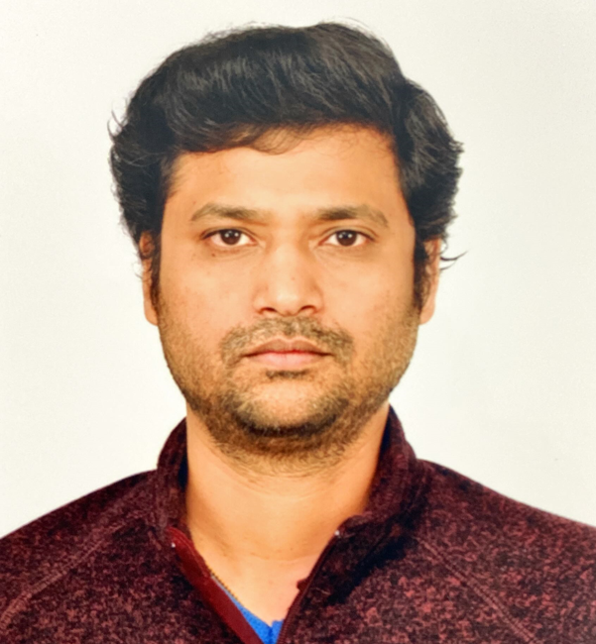 |  |  | VIjay Anand
 |  |  | Director, Software Development
contact  437-245-5005  vijayanandg@yahoo.com  www.linkedin.com/in/vijay-38601033  SKILLS  - Technology Strategy & Roadmapping  - Project/Program Management & Stakeholder Engagement  - Enterprise Application Architecture  - Performance Management  - Microservices Architecture  - Cloud-native Technologies (AWS, Azure)  - API Integration, RESTful APIs  - Architecture Patterns (Microservices, SOA, Event Sourcing)  - Kafka  - Application Insights, Monitoring, Alerting  - Azure Key Vault  - Integration patterns Domain-Driven, APIs, Messaging, etc.  - Java/Spring Boot  - NoSQL Databases (MongoDB, Couchbase)  - Relational DBs (MS SQL, Oracle)  - Team Leadership and Mentoring  - DevOps CI/CD Processes, Source control, Release Pipelines  - Kubernetes, Openshift ECS, Docker  - Web and Mobile Frameworks (Angular, React, Node, React Native, RWA)  - Java, Spring Boot  - System Monitoring and Performance Optimization  Certifications  - IBM Certified Watson IoT platform Developer |  |  | Profile  Accomplished technology leader with over 19 years of professional IT experience, known for successfully managing high-value programs from inception to delivery. Have a proven track record in leading cross-functional teams to deliver high-impact projects, adhering to established project management methodologies, and managing budgets efficiently.  Experienced in cloud-native architectures, including Azure and AWS, and API/microservice development. Proficient in defining architectures, documenting guidelines, and crafting technology roadmaps in collaboration with business and IT leadership.  Strong background in App development and DevOps practices, encompassing CI/CD processes, Agile methodologies, release management, and stringent security compliance.  Expertise in mentoring teams to deliver scalable solutions aligned with enterprise architecture and governance frameworks, driving digital transformation initiatives to streamline business processes and enhance customer experiences. Known for fostering a collaborative and innovative environment, empowering engineers, and ensuring strategic alignment with business objectives.  My experience includes optimizing system performance, implementing robust CI/CD processes, and ensuring compliance with security standards such as SOX/GDPR. I have effectively managed stakeholder engagement, translating business requirements into IT solutions, and providing comprehensive training and support during deployments.  WORK EXPERIENCE  VP, Senior Manager, Citi Mar 2022 – Present    - Directed cross-functional teams of 27+ associates to deliver high-impact projects in Wholesale Credit Risk Technology, ensuring alignment with business goals and customer expectations. Actively contributed to the overall success of project portfolios by driving continuous improvement initiatives.  - Fostered strong relationships with stakeholders to elicit, analyze, and translate business requirements into IT solutions. Collaborated effectively with business and IT partners to identify optimization opportunities and address pain points, ensuring all projects are managed within budget and on schedule.  - Oversaw project lifecycle management using established Project Management methodologies, guaranteeing consistency and quality in execution. Developed and controlled project budgets, managing expenditures to align with agreed value delivery and spending plans.  - Proven track record in leading digital transformation initiatives that leverage technology to streamline business processes and enhance customer experiences. Spearheaded the deployment and optimization of Spring Boot-based microservices within AWS EKS/OpenShift clusters, ensuring high performance and reliability.  - Ensured thorough analysis, documentation, and testing of program development, process flows, and specifications. Developed training materials and oversaw user training during deployment, facilitating smooth transitions and maximizing adoption.  - Coached, motivated, and directed staff from various organizations to understand business needs and identify solutions that align with customer objectives and IT strategy, enhancing collaboration and innovation.  - Accountable for identifying security and compliance requirements within business processes and ensuring their integration into solution design to mitigate risks.  - Demonstrated knowledge in data analysis, storytelling, and visualization, employing robust data solutions using MongoDB to manage and scale data-intensive applications effectively.  - Enhanced API response times by 200% through advanced policies for response caching, spike handling, and rate limiting, contributing to improved service delivery and user satisfaction.  - Conducted regular performance reviews and implemented a robust CI/CD process using OpenShift/Kubernetes, fostering a culture of continuous improvement within teams.  Sr Manager, Cognizant Technology Solutions Oct 2016 - Feb 2022    - Managed a diverse engineering team of over 40 associates, ensuring alignment with strategic goals while fostering innovation and collaboration to deliver exceptional customer experiences.  - Designed and implemented a serverless event processing system using Azure Java Functions, enhancing scalability and responsiveness through a robust event-driven architecture.  - Engineered Java/Spring Boot serverless functions that supported EventHub, HTTP, and Timer-based triggers, integrating EventHub triggers for efficient real-time streaming data processing and analysis.  - Developed and maintained mission-critical applications using MS SQL Server, optimizing performance and reliability through effective database design and management.  - Successfully established and led a team from inception to over 100 resources in the IoT Facility Management domain, ensuring the successful execution of projects within budget and timelines.  - Led the design and implementation of scalable serverless solutions, establishing robust CI/CD pipelines with Azure DevOps and GitHub Actions, while implementing comprehensive logging and monitoring solutions using Azure Application Insights.  - Architected and developed Java Spring Boot-based monitoring frameworks and custom TRIRIGA functionalities for McDonald’s, contributing to enhanced operational effectiveness and efficiency.  Technology Lead, Infosys Ltd., Chicago, USA  Dec 2005 – Oct 2016    - Led a team of 20 cross-functional experts in the design and implementation of PPLM's Global Loyalty Program application.  - Managed AWS EC2 deployments and facilitated the integration strategy for mobile and application services using Spring and RESTful APIs.  - Architected and developed Java/J2EE-based applications for airline joint ventures.  - Led as technical lead for the design and implementation of Telstra’s Order Management System (OMS), enabling customers to order mobile hardware and services online with features for product comparison, stock visibility, user access management, and order status tracking.  - Deployed AWS EKS with OpenShift to orchestrate containerized applications, ensuring scalability and resilience in a cloud-native environment.  - Utilized OpenShift's containerization capabilities to streamline deployment and management of Java and Node.js microservices, optimizing performance and resource utilization.  - Implemented Node.js microservices architecture, leveraging its asynchronous event-driven nature for modularizing backend functionalities and seamless integration with RESTful APIs, databases (Couchbase, MongoDB), and external services.  - Provided technical leadership and oversight throughout the project lifecycle, including roadmap development, solution architecture, DevOps implementation, and successful project execution.  - Designed SOAP-based services and Oracle PL/SQL for seamless revenue sharing across multiple airlines.  - Led the architecture and development of Java/J2EE-based interline revenue accounting systems for United Airlines.  - Developed and maintained Java/J2EE-based passenger revenue accounting systems for United Airlines.  - Led the implementation of SOX/GDPR compliance frameworks ensuring regulatory adherence and enhancing data security.  EDUCATION  Bachelor of Technology, Computer Science May 2001 - May 2005  Jawaharlal Nehru Technological University, India

